MIT Test Script
Test Script Filename: CUR_ZOK2_0001 |  |  | Date Tested: 5/17/10 |  |  | Cycle: SIT in SH1
Scenario Name: Create new EB Adjustment key |  |  | Menu Path or URL: From SAP main menu /nZOK2
Profile or Role of Tester(s): Z_GL_OVERHEAD_COSTING_SHEETS_M; ZMIT |  |  | Script Owner: R. Casey
Business Process Owner: L. Monks |  |  | Approver: R. Casey |  |  | Tester / Executed By: R. Casey
Purpose/Objective of Test Script: Test the transactions are Unicode compliant for the SAP Hardware Upgrade project.
Prerequisites: The cost object used to verify the new key must exist in the test system. The tester must have the ZMIT menu assigned in order to display the cost object.
Step No. | Test Step Description / Transaction Code | Input Data / Master Data |  | Expected Results | Actual Results  and  Pass / Fail / Comments |  | RT# (Fails)
 | Execute transaction ZOK2 | None |  | SAP displays the “Change View Overhead Key Master Table” screen. | Same  Pass
 | Enter new EB Adjustment key via copying an existing key | Page down to bottom of list.  Select the last entry.  Press the COPY AS button |  | SAP displays the “Change View Overhead Key Master Table: Overview of selected set screen;” showing a line for the copied key | Same  Pass
 | Enter and validate data | Change the OH KEY number shown (increment the OH KEY field on the copied entry by one number)  Enter Text for the key: .99 On - .99 Off  Press ENTER to validate the entry  NOTE FOR EB ADJUSTMENTS  Do NOT use keys 029990, 029991 or 029999 as the COPY FROM value. Copy from, and increment from, the last key in the table BEFORE 029990. |  | SAP returns the same screen with a message stating “Number of Copied Entries: 1.” | Same  Pass
 | Save the new key | Press the SAVE icon |  | SAP returns the same screen with a message stating “Data was saved.” | Same  Pass
 | Display the key via cost object display | Execute transaction ZCO3  Enter 1777900  Press ENTER  Click into the EB ADJUSTMENTS field  Press the match code indicator ()  Page down to the bottom of the list; confirm the new key appears. |  | SAP displays the cost object and the user can display the new key via the match code indicator. | Same  Pass

Additional Comments:

Test Script Execution Sign-off
Executed By / Tester | Reviewer (QA or other designate) | Business Process Owner / Approver
R. Casey |  | R. Casey

Unit testing in SF2.
Step 1:
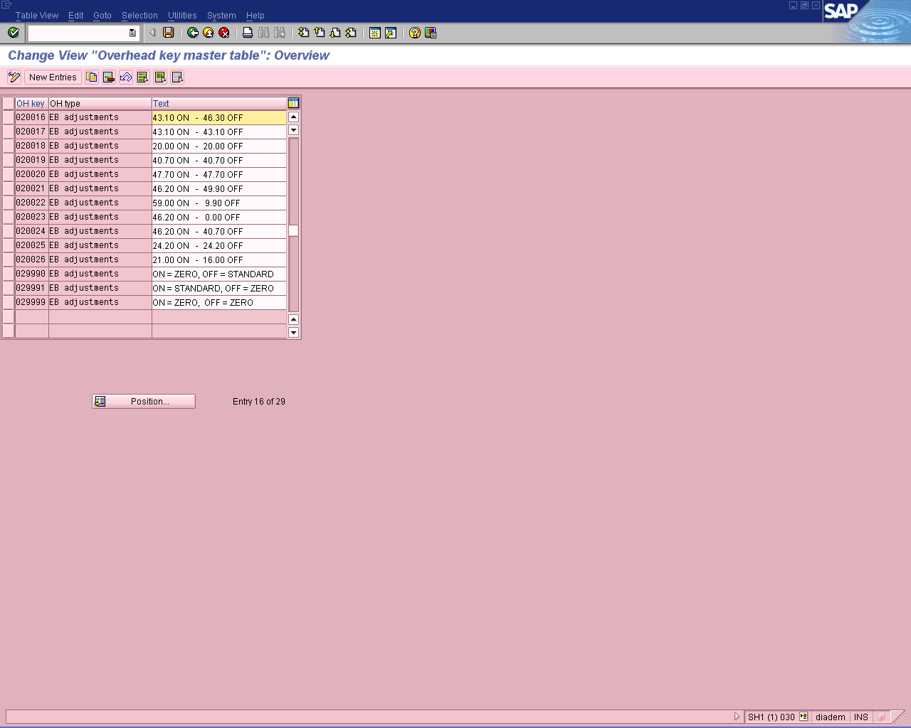
Step 2:
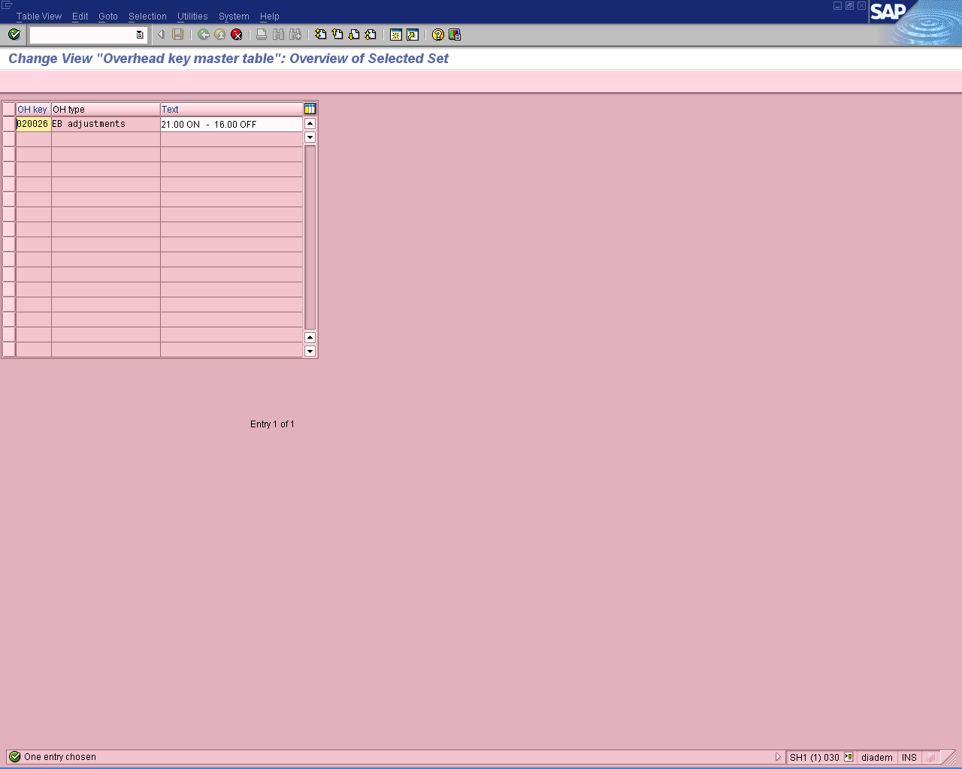

Step 3:
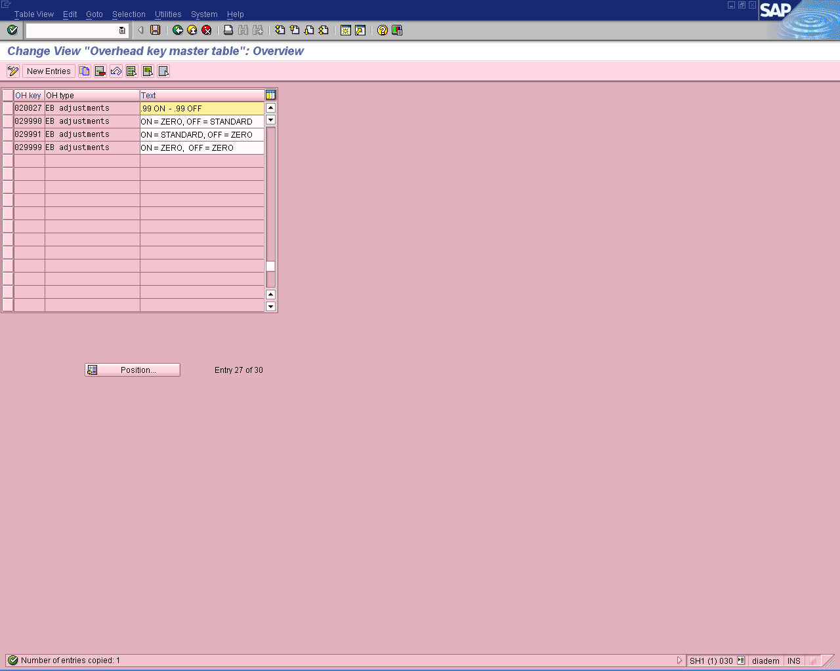

Step 4:
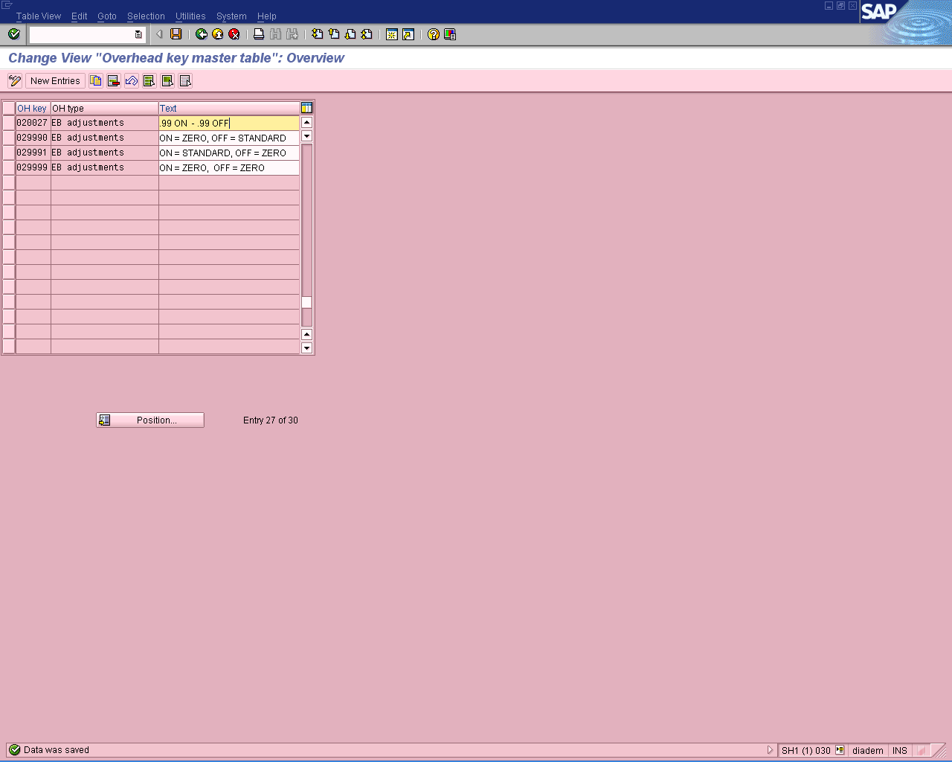

Step 5:
