MIT Test Script
Test Script Filename: CUR_ZOK4_0001 |  |  | Date Tested: 5/17/10 |  |  | Cycle: SIT in SH1
Scenario Name: Create new Planning Adjustment key |  |  | Menu Path or URL: From SAP main menu /nZOK4
Profile or Role of Tester(s): Z_GL_OVERHEAD_COSTING_SHEETS_M; ZMIT |  |  | Script Owner: R. Casey
Business Process Owner: L. Monks |  |  | Approver: R. Casey |  |  | Tester / Executed By: R. Casey
Purpose/Objective of Test Script: Test the transactions are Unicode compliant for the SAP Hardware Upgrade project.
Prerequisites: The cost object used to verify the new key must exist in the test system. The tester must have the ZMIT menu assigned in order to display the cost object.
Step No. | Test Step Description / Transaction Code | Input Data / Master Data |  | Expected Results | Actual Results  and  Pass / Fail / Comments |  | RT# (Fails)
 | Execute transaction ZOK4 | None |  | SAP displays the “Change View Overhead Key Master Table” screen. | Same  Pass
 | Enter new Planning Adjustment key via copying an existing key | Press the NEW ENTRIES button. |  | SAP displays the “Change View Overhead Key Master Table” screen, with a new line created for the new key. | Same  Pass
 | Enter and validate data | Enter a new PLANNING KEY number (increment the last key by one number) 040001  Enter Text for the key: TEST FOR UNICODE COMPLIANCE  Press ENTER to validate the entry |  | SAP displays the “Change View Overhead Key Master Table” screen, showing the just entered data. | Same  Pass
 | Save the new key | Press the SAVE icon |  | SAP displays the NEW ENTRIES: Overview of new entries screen. | Same  Pass

Additional Comments:
NOTE FOR PLANNING ADJUSTMENT KEYS:
As of 5/14/10 planning adjustment keys have not been used and there are no entries in the production tables. This unit test script tests whether the table can be maintained. There is no SIT for this particular key due to the fact it’s not used in production.
There is no production validation step since this data / function isn’t used in production.

Test Script Execution Sign-off
Executed By / Tester | Reviewer (QA or other designate) | Business Process Owner / Approver
R. Casey |  | R. Casey

Unit testing in SF2.
Step 1:
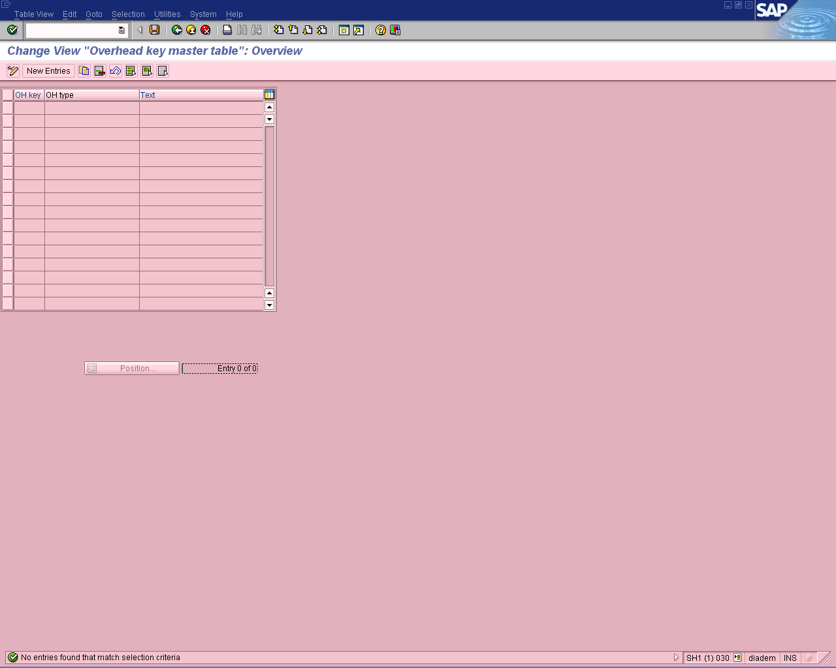
Step 2:
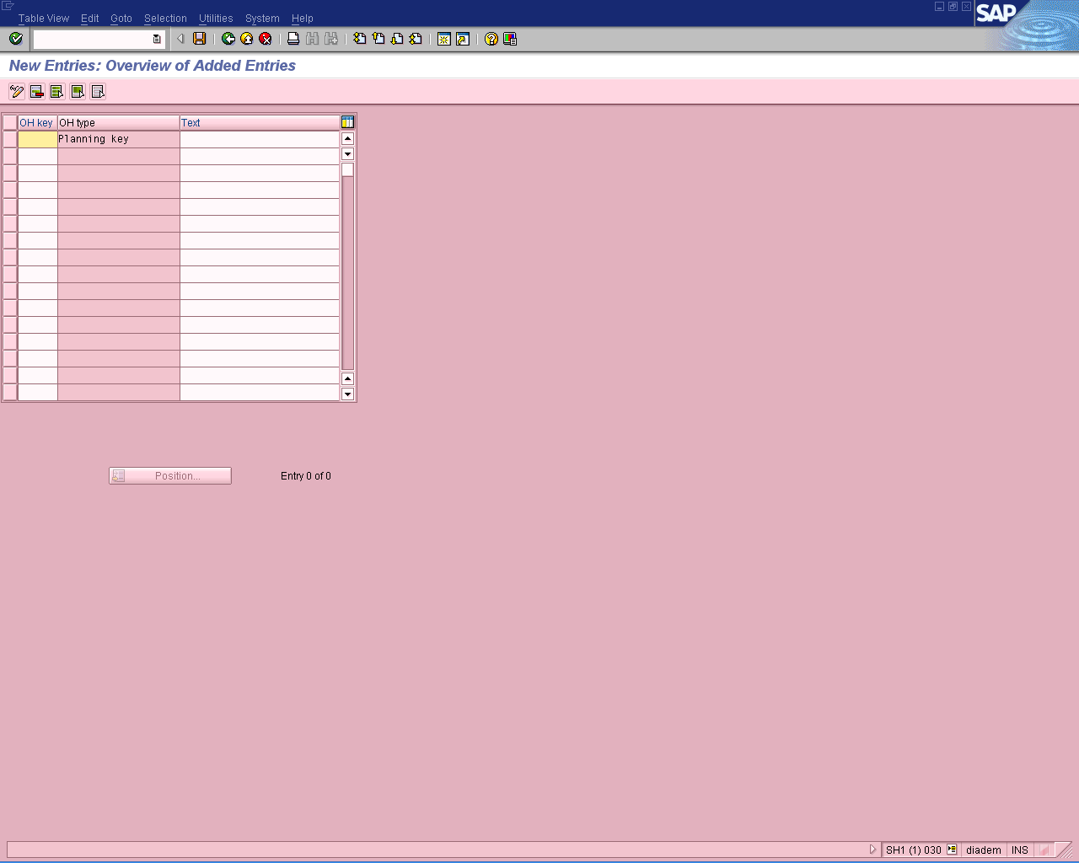

Step 3:
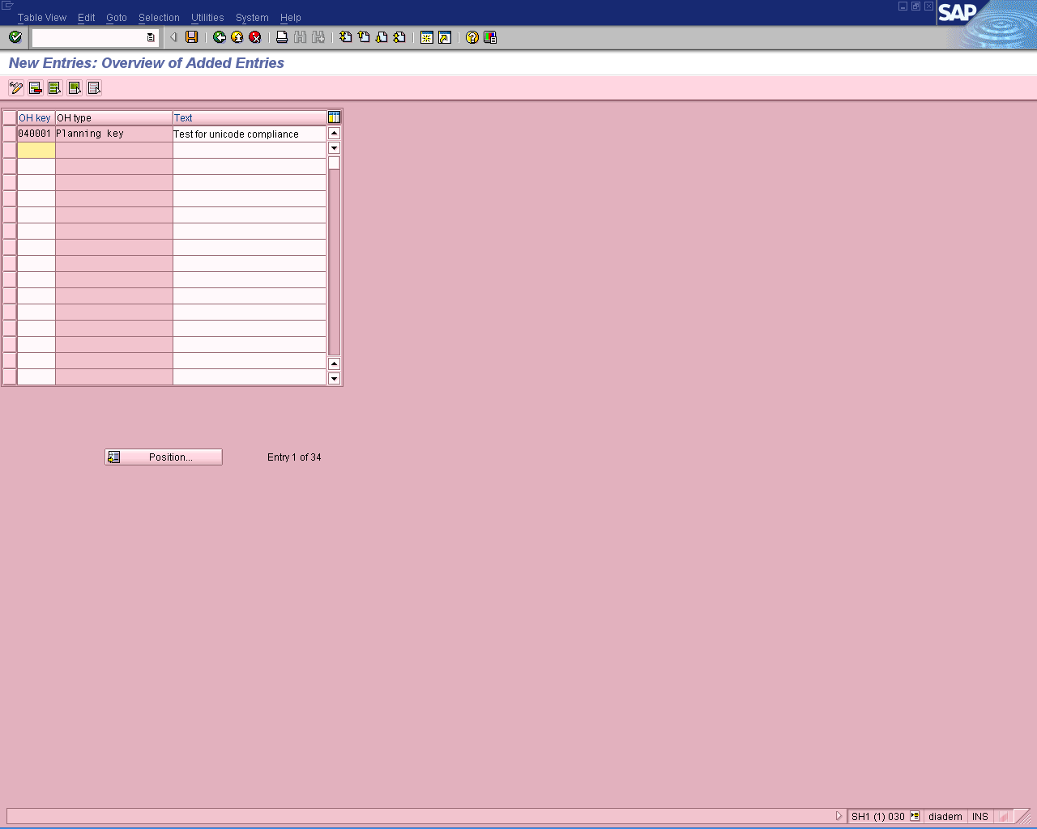

Step 4:
