MIT Test Script
Test Script Filename: CUR_ZOKY_0001 |  |  | Date Tested: 5/17/10 |  |  | Cycle: SIT in SH1
Scenario Name: Display Overhead Key Master Table |  |  | Menu Path or URL: From SAP main menu /nZOKY
Profile or Role of Tester(s): Z_GL_OVERHEAD_COSTING_SHEETS_M; ZMIT |  |  | Script Owner: R. Casey
Business Process Owner: L. Monks |  |  | Approver: R. Casey |  |  | Tester / Executed By: R. Casey
Purpose/Objective of Test Script: Test the transactions are Unicode compliant for the SAP Hardware Upgrade project.
Prerequisites: The cost object used to verify the new key must exist in the test system. The tester must have the ZMIT menu assigned in order to display the cost object.
Step No. | Test Step Description / Transaction Code | Input Data / Master Data |  | Expected Results | Actual Results  and  Pass / Fail / Comments |  | RT# (Fails)
 | Execute transaction ZOKY | None |  | SAP displays the “Display View Overhead Key Master Table” screen. This view includes all adjustment keys (lab allocation, EB adjustments, OH adjustments and Planning keys). | Same  Pass
 | Display the different adjustment keys | Page up and down through the list |  | SAP displays the “Display View Overhead Key Master Table” screen, showing all the entered adjustment keys, including the new keys entered when testing ZOK1, ZOK2, ZOK3 and ZOK4. | Same  Pass

Additional Comments:

Test Script Execution Sign-off
Executed By / Tester | Reviewer (QA or other designate) | Business Process Owner / Approver
R. Casey |  | R. Casey

Unit testing in SF2.
Step 1 – Initial display of table:
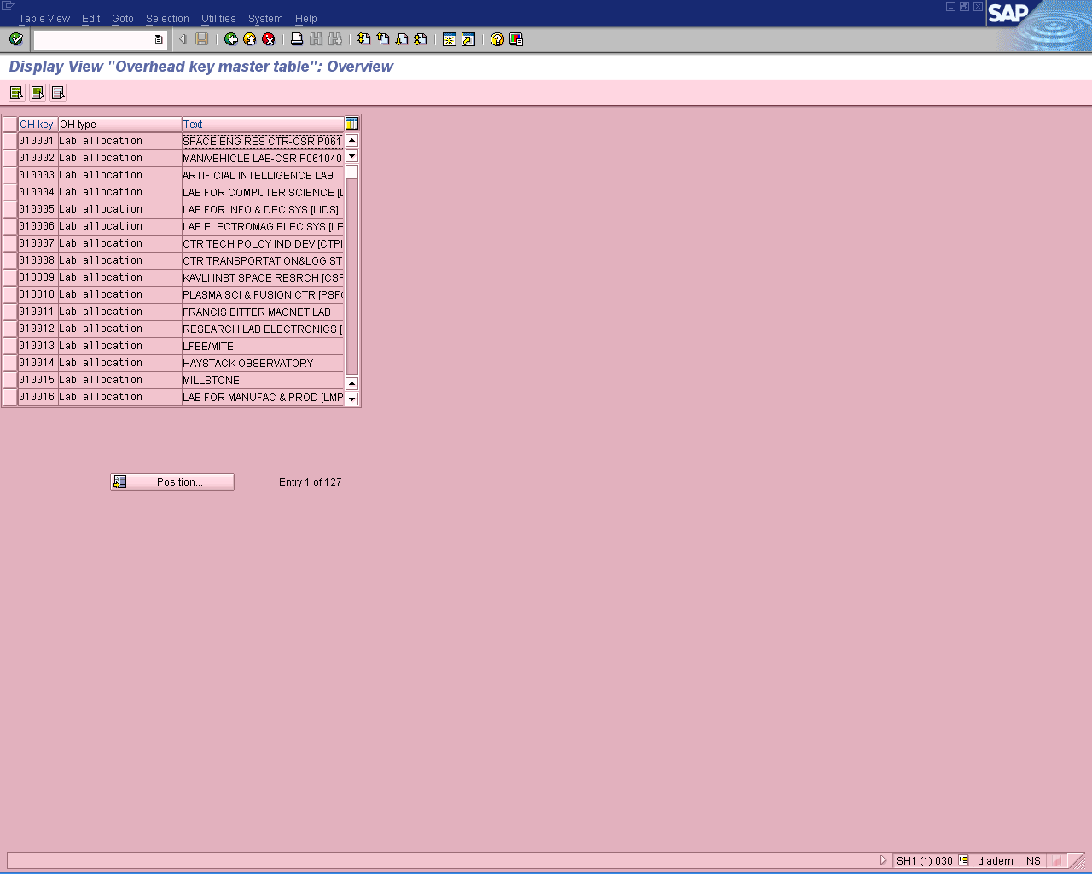

Show data entered for ZOK1 test:
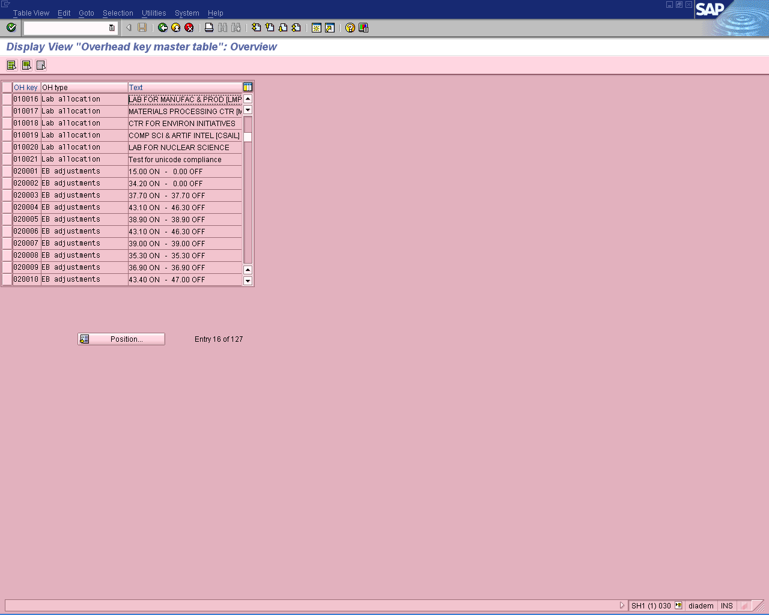

Show data entered for ZOK2 test:
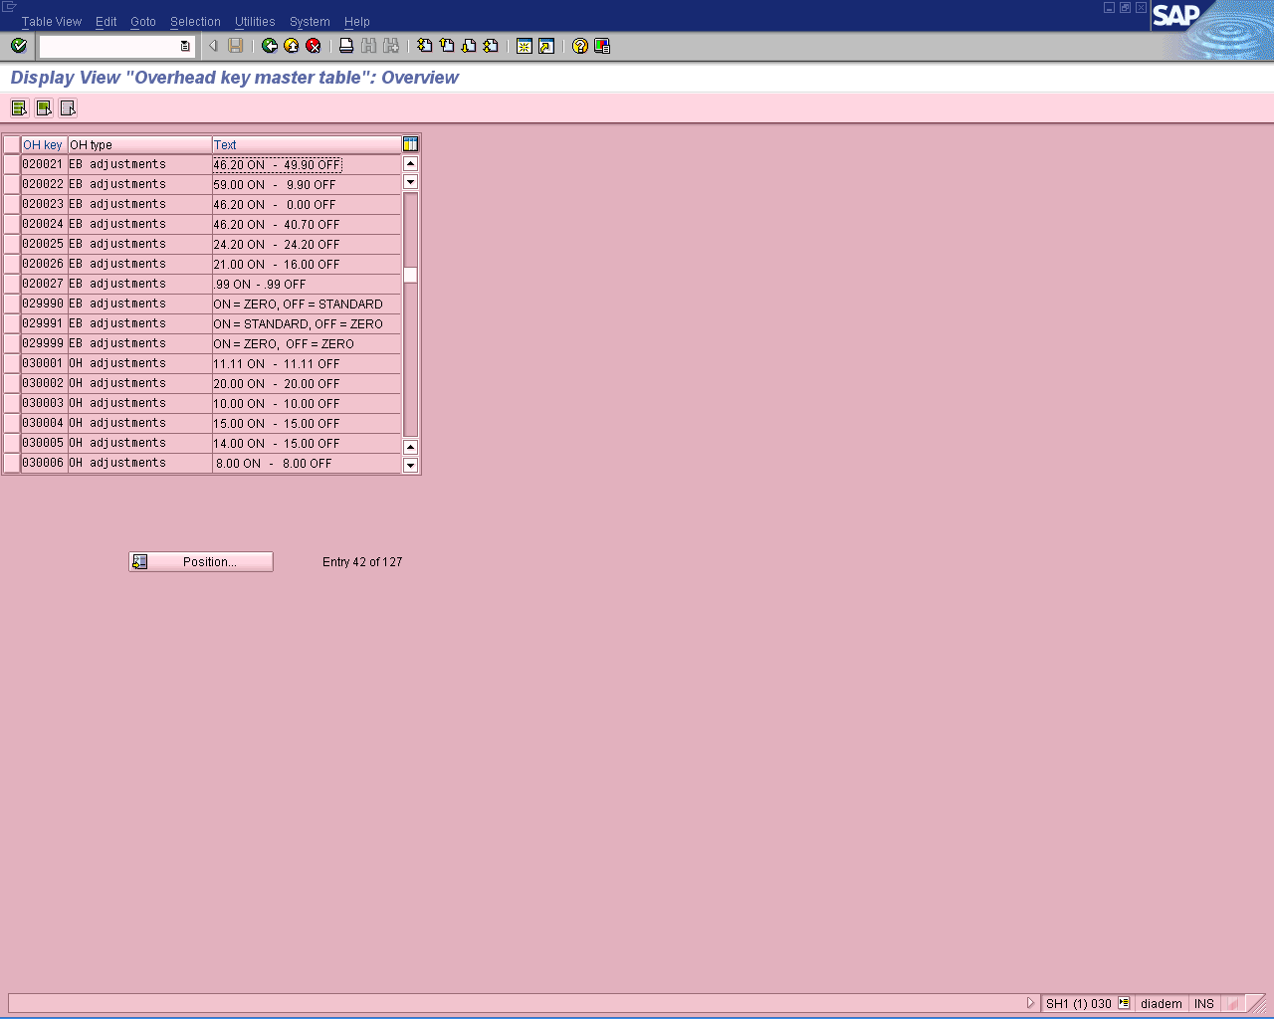

Show data entered for ZOK3 & ZOK4 test:
