Quality Center
IS&T Training Guide
Contents
Introduction 2
Terms 2
System Requirements 2
Logging into Quality Center – As a First Time User or To Receive Updates 3
Logging into Quality Center as a Returning User 5
Logging Out of Quality Center 6
Navigating the Quality Center 7
Key Navigation Notes 7
Quality Center Applications 7
Working with Test Cases 8
Viewing Test Cases 8
Adding a Test Case 9
Adding Test Steps to a Test Case 11
Add an Attachment to a Test Case 12
Updating a Test Case 13
Executing Test Cases in Test Lab 15
Display Existing Test Sets 15
Create a Test Set 16
Add Test Cases to a Test Set 16
Run a Test 17

Copyright © 2011 by Massachusetts Institute of Technology. All Rights Reserved.

Introduction
Quality Center is the web-based application used by MIT as a centralized repository for test cases and test results. The IS&T Quality Assurance team administers access to Quality Center. Staff in VPF and other administrative departments are provided access to Quality Center so that they may use it to manage their user acceptance testing of IS&T supported systems. Most commonly, Quality Center is used to support the testing of MIT’s SAP applications.
This guide provides instructions on how to:
- Review existing test cases
- Add a new test case
- Update existing test cases
- Create test sets
- Run tests and record test results

Terms
Test Case: A test case identifies a system feature of function that needs to be tested. For example, “Delete a JV” could be a test case. Within Quality Center, Test Case is the module where test cases can be viewed, created, and updated.
Test Steps: Within a test case, the test steps identify the specific procedures that need to be taken to execute the test case.
Test Lab: In Quality Center, the Test Lab is where you create test sets to organize your specific test runs.
Test Set: A test set is created for a test run. Test cases are copied into the test set and then executed.
Test Results: When you execute a test set, you record the test set’s pass or fail condition.

System Requirements

PC Users | Windows XP, Vista, or Windows 7  Internet Explorer 7 or greater
Mac Users | VMware installed on your system, enabling you to access Quality Center as a PC
Off Campus Users | Access to Quality Center from outside the MIT network can only be made through a VPN connection. For more information, visit https://ist.mit.edu/services/software/anyconnect

Logging into Quality Center – As a First Time User or To Receive Updates
If you are a first time user of Quality Center, you need to perform the following steps to download Quality Center updates your system. For this download process to work, you need to:
- Be the administrator to your machine – you can check this by opening your system’s Control Panel and viewing your User Accounts.
- Run Explorer as ‘Administrator’ (per the following steps)
You will also need to perform the following steps if IS&T QA informs you that there are new Quality Center updates to download.
- From the Start menu, locate the listing for Internet Explorer and right click on it to display the pop-up options menu
- From the menu, select Run as Administrator – Internet Explorer will open.
- In Internet Explorer, go to https://qualitycenter.mit.edu. The Quality Center window displays.
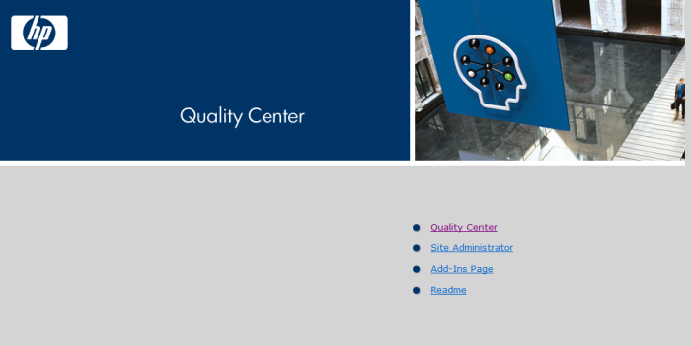
- Click the Quality Center link.
Updates will download to your system. Be patient – depending on the speed of your connection, the download process may take a minute or two. Once the finishes, the Login fields display.
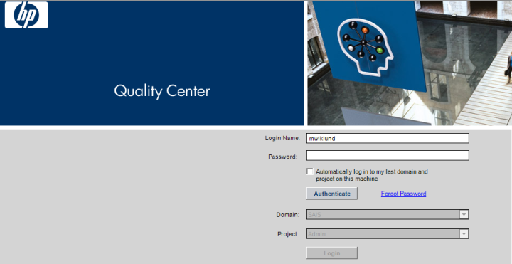
- Enter your login name if it does not already display.
- Enter your password.
- Click the Authenticate button.
The system displays your default Domain and Project settings.
- Accept the displayed Domain and Project settings or select different options from the drop-down lists.
- Click Login
An HP Quality Center welcome dialog may display, providing links to a number of Help resources. These resources are available through the Quality Center Help menu. Recommend that you select the Don’t show this again option and click Close. The Quality Center window will display.

Logging into Quality Center as a Returning User
Perform the following steps if you are a return user to Quality Center.
- Open Internet Explorer
- Go to https://qualitycenter.mit.edu. The Quality Center window displays.
- Click the Quality Center link.
Updates will download to your system. Be patient – the process may take a minute or two. Once the download process finishes, the Login fields display.
- Enter your login name if it does not already display.
- Enter your password.
- Click the Authenticate button.
The system displays your default Domain and Project settings.
- Accept the displayed Domain and Project settings or select different options from the drop-down lists.
- Click Login
An HP Quality Center welcome dialog may display, providing links to a number of Help resources. These resources are available through the Quality Center Help menu. Recommend that you select the Don’t show this again option and click Close.
The Quality Center window will display.

Logging Out of Quality Center
When you are done using Quality Center, you must Logout of the application. Do not exit Quality Center by closing your browser window.
Do you have Test Cases to Check In! Before logging out of Quality Center, you should always check-in the test cases that you may have checked out – this is discussed later in the document.
To logout, click the Logout button in the upper right corner of the Quality Center window. Logging out returns you to the Quality Center login window.

Navigating the Quality Center
Quality Center opens inside your Internet Explorer browser.

Key Navigation Notes
- Do not use the Internet Explorer Back, Forward, Refresh, or Home buttons to navigate Quality Center. Use only the navigation buttons within the Quality Center application.
- Do not close Internet Explorer to close Quality Center – always logout of Quality Center.
- The Quality Center Help is actually pretty good. Use it!
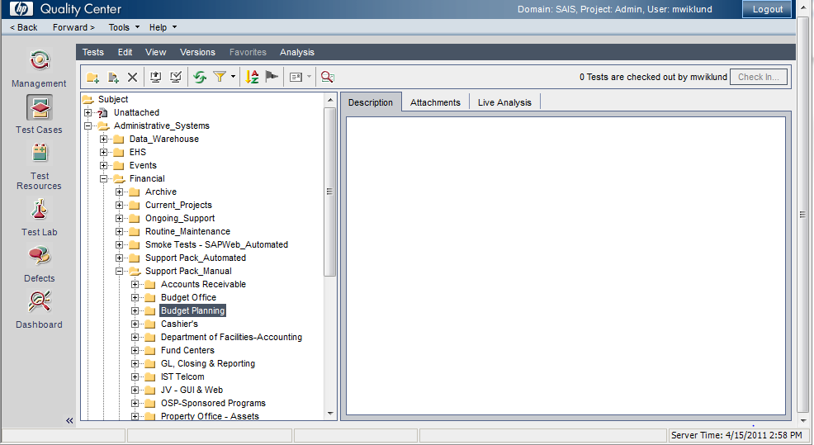

Quality Center Applications
The applications you are allowed to access are listed along the left side of the window. They include:
Management | Not used at MIT
Test Cases | Used to store test cases
Test Resources | IS&T Quality Assurance uses this area to maintain their automated test cases.
Test Lab | Used to manage test runs and record test results.
Defects | IS&T Quality Assurance uses this area to track open RT requests
Dashboard | IS&T Quality Assurance uses this area to create and run metrics reports for testing

Working with Test Cases
Test Cases is the Quality Center module where you can view, create, and update test cases.

Viewing Test Cases
Click the Test Cases module button to display the Test Cases area of Quality Center.
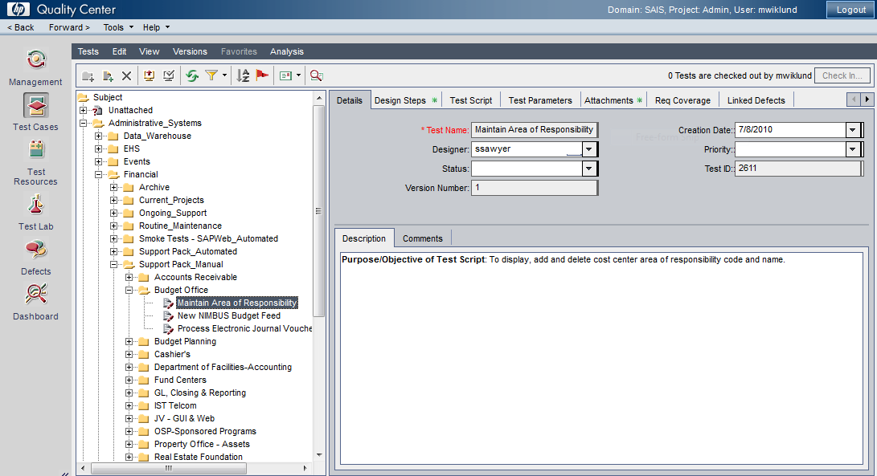
The left pane displays a hierarchical structure that organizes test cases. Most test cases for User Acceptance testing will be found under Subject > Administrative Systems > Financial > Support Pack Manual. Test cases display at the lowest level of the hierarchy. User the + and – buttons to expand and collapse the view.
The right pane shows information for the selected test case. Information in this panel is tabbed. Tabs include:
Details | Descriptive information about the test case
Design Steps | Procedural steps to execute the test case
Test Script | Used by IS&T QA for automation
Test Parameters | Used by IS&T QA for data parameters
Attachments | Use this tab to attached documents, spreadsheets, or other files pertinent to the test case
Reg Coverage | If the test case is linked to requirements, this tab will display the requirements
Linked Defects | Not used. IS&T QA uses Request Tracker (RT) to document and track defects.

Adding a Test Case
Perform the following steps to create a new test case in Quality Center.
- Open the Test Cases area of Quality Center
- Select the folder you wish to contain the new test case.
- Click the New Test button to display the Create New Test dialog.
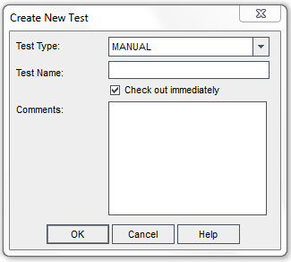
- Leave the Test Type defaulted to Manual.
- Enter a Test Name.
- Accept the Check out immediately selection.
- Click OK.
The test case is now added. You can see it in the hierarchy attached to the selected folder. You can drag and drop the test case to a different folder if necessary. You cannot delete the test case (contact IS&T QA if the case should be deleted).
Be Sure To Check In the New Test Case When You Have Completed Work on it!
When you create a new test case, it will have a checked out status. You can see a message to this effect on the right side of the Quality Center window:
No one else but you can see it.
- Once you complete work on the test case and it is ready to be used, be sure to check it in, by clicking the Check in button. The Pending Check in dialog displays.
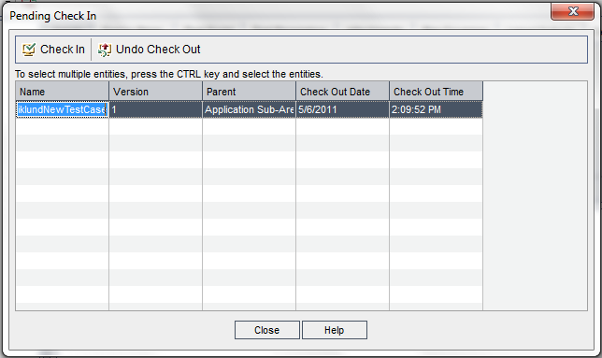
- Click Check In. The Check In dialog now displays.
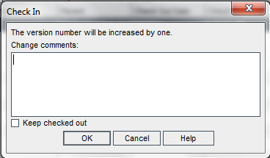
- Enter a comment for the version being checked in.
- Click OK. This returns you to the Pending Check in dialog.
- Click Close to close the Pending Check In dialog.

Adding Test Steps to a Test Case
- Open the test case.
- Open the Detail Steps tab, as shown below.
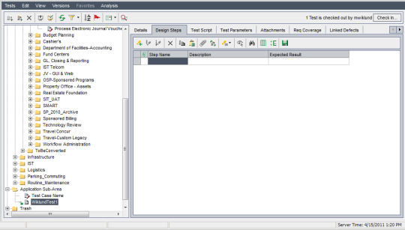
- Click the New Step button to open the Design Step Editor.
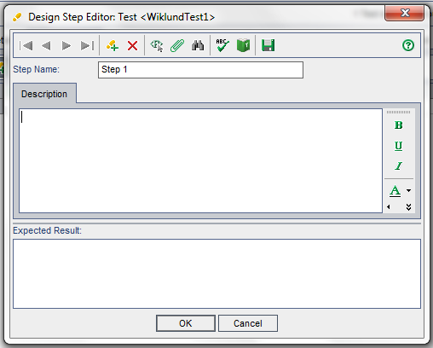
- Accept the default Step Name – Quality Center defaults to the next available step number. Later, you can re-sequence and/or renumber your steps.
- Enter into the Description field the action to be taken with this step.
- Enter the Expected Result.
- Click OK. The step is saved and added to the test case
- Repeat steps 3-7 to add more steps.
- Notice that the test case you have been working on is checked out.
- Be sure to check in your updated test case!

Add an Attachment to a Test Case
With the Test Case area if Quality Center, the Attachment tab allows you to:
- Attach a file
- Identify a URL link
- Create a screen capture and save it to the test case
- Capture your PC’s system information
- Attach the contents of your Clipboard
Here’s how
- Open the test case
- Display the Attachment tab
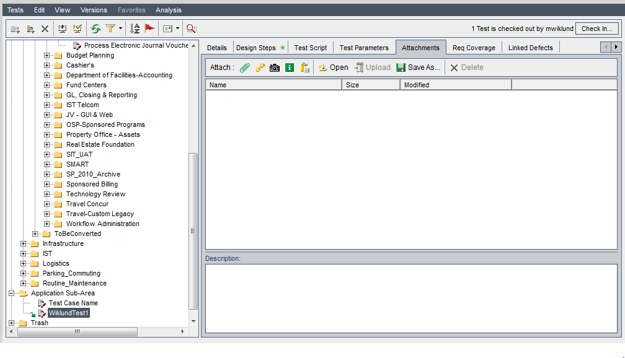
Note the button bar in the Attachment tab:

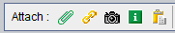

Click the paperclip to attach a file – a dialog box displays allowing to search for and select the file to attach
Click the chain icon to enter a URL – a dialog displays allow you to enter the URL
Click the camera icon to attach a screen shot – a dialog displays with instructions on how to perform the capture.
Click the system information button to view your system’s information
Click the clipboard icon to create an attachment of information currently stored in your system’s clipboard.
Notice that the test case you have been working on is checked out.
Be sure to check in your updated test case!

Updating a Test Case
Once you begin to update an existing test case, the following dialog displays
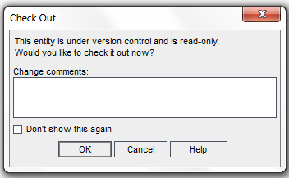
- Enter the nature of the update into the Change Comments field
- Click OK
- The text case is now checked-out.
- Complete your update.
- Notice the checked out message in the top right of the window.
- Click the Check in button
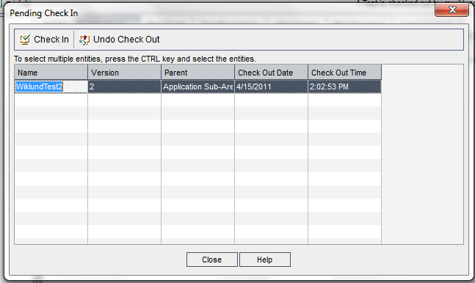
- Select the test case you wish to check in.
- Click the Check In button – the selected test case is checked in and clears from the dialog box.
- Click Close to close the dialog box.

Executing Test Cases in Test Lab
In Test Lab, you will find the test sets for each test run. These test sets contain the test cases to be executed.

Display Existing Test Sets
Click the Test Lab button to display the Test Lab area
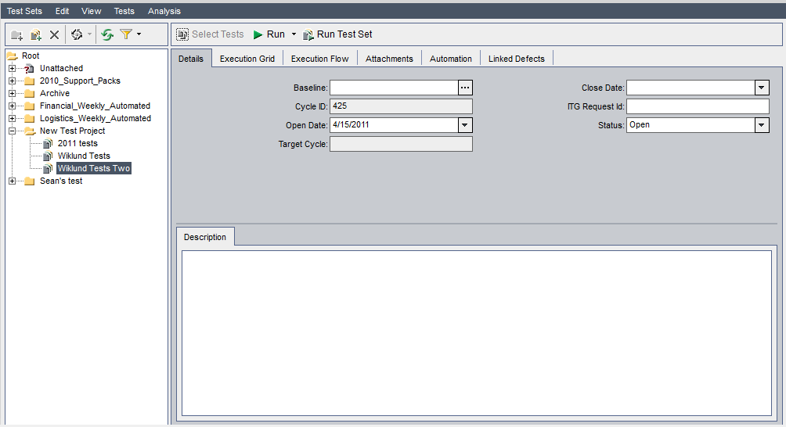
The left pane displays a hierarchical structure that organizes test sets. Each folder represents a test set. Within a test set you will see the test cases assigned to the set. In general, IS&T QA will create test set folders for user acceptance testers, but you can also create your own test sets.
The right pane shows test execution information for the selected test case. Tabs include:
Details | Descriptive information about the test set
Execution Grid | Use this tab to identify the test cases to be executed in this test. Also use this tab to execute test cases and record their results
Execution Flow | Used by IS&T QA
Attachments | Use this tab to attach files, URLs, or screen shots to the test set.
Automation | Used by IS&T QA
Linked Defects | Used by IS&T QA

Create a Test Set
It is recommended that test sets be created by IS&T QA or the IS&T Business Analyst associated with the testing activity. Before creating a test set, consult with them.
- Navigate to the Test Lab section of Quality Center
- Select the folder which will contain the new Test Set.
- Click the New Test Set button The new test set is added to the test set hierarchy

Add Test Cases to a Test Set
It is recommended that test cases by added to test sets by IS&T QA or the IS&T Business Analyst associated with the testing activity. Before updating a test set, consult with them.
- Select the Test Set within which the Test Case(s) will be executed.
- Open the Execution Grid tab.
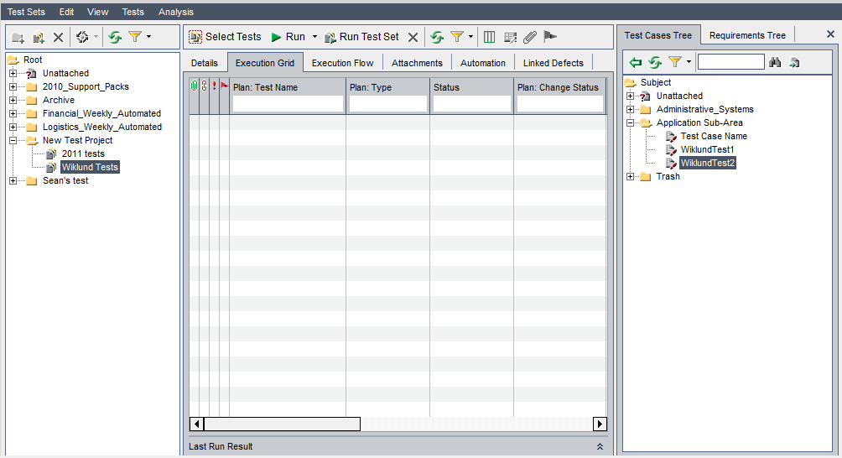
The Test Cases Tree on the right side of the window displays the test case hierarchy.
- In the Test Cases Tree section of the Test Lab, expand the tree to display the test cases you wish to run in the test set.
You can select a folder or an individual test case. You can select many folders or test cases by holding down the Control key and click the desired selections.
- Click the Add Tests to Test Set button. The test cases will now be listed in the Execution Grid.
- Add as many test cases as appropriate to your test set.

Run a Test
- Open the Test Lab section of Quality Center
- Select the Test you wish to run.
- Click the Run button. The Manual Runner dialog displays.
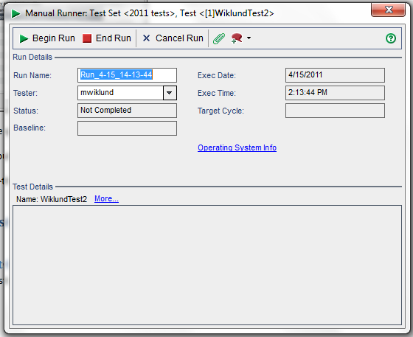

- Click Begin Run. The following dialog displays showing you the Design Steps for the test case.
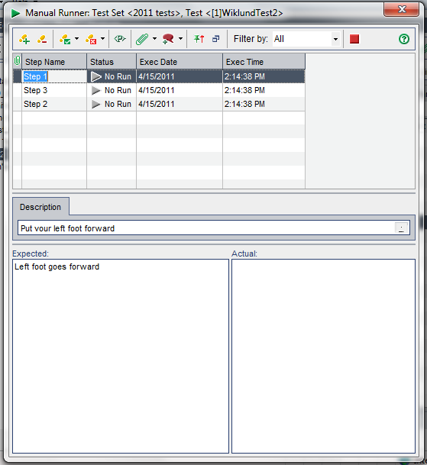
Updating the Expected Results: You may update the expected results text. You should do this if the pass criteria has changed since the test case was last updated. Updating the expected results will check-out the test case.
Always enter Actual Results comments if the case fails.
- Perform the action for the first step.
- Enter the Actual results.
Option | Button | Steps
Pass a Step |  | Click this Pass Step button to pass the step
Pass All Steps |  | Click the down arrow beside the Pass Selected button and from the options menu, select Pass All
Fail a Step |  | Enter your Actual results first!  Click the Fail Step button to fail the step.
Fail All Steps |  | Enter your Actual results first!  To fail all the steps, click the down arrow beside the Fail Selected button and from the options menu, select Fail All.

- When you finish testing the case, click the End Run (red square button). This closes the dialog box and returns you to the Test Lab.
- If you updated a test case’s expected results, be sure to check in the test case!

